***Experiment 9***

**Aim:** Graph Analytics with GraphX: Explore graph-structured data using Apache Spark's GraphX library, and perform graph analytics tasks such as computing centrality measures or detecting communities.

***Spark GraphX Analytics:***

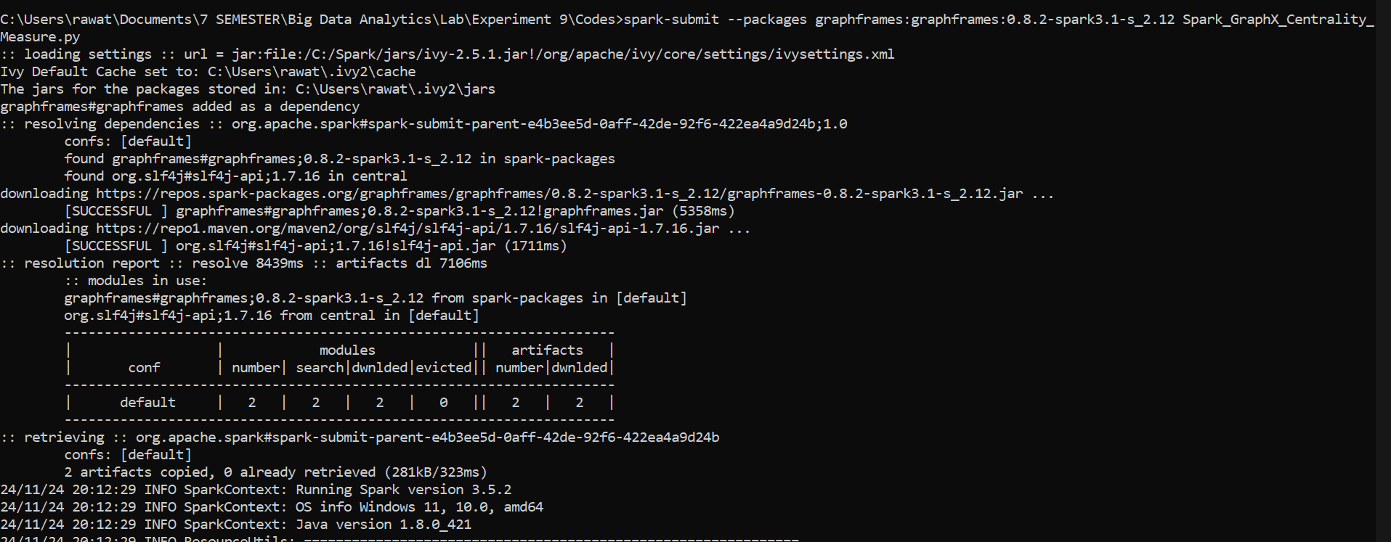

***Fig 1: Installing Required Packages***

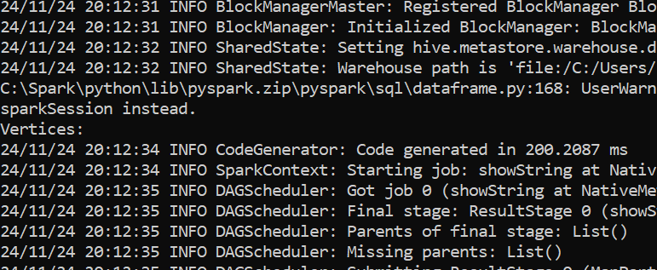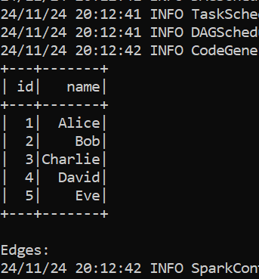

***Fig 2: Dataset Schema***

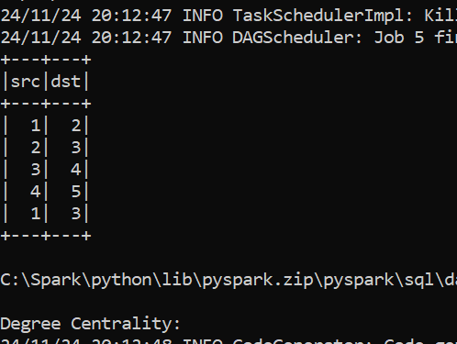

***Fig 3: First Rows and Classes of Dataset***

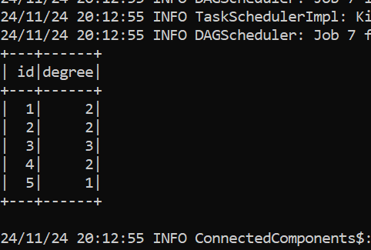

***Fig 4: Source and Destination***

***Fig 5: Source ID and Degree***